Resume of Rashel Hossain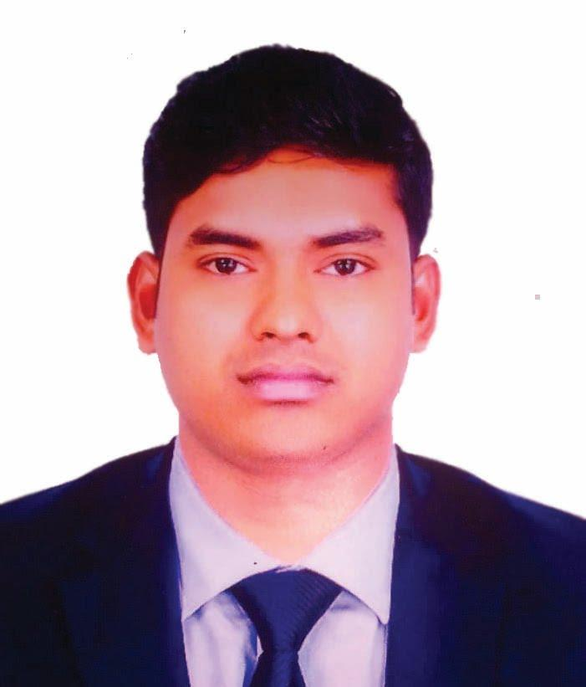

Contact No: 01942908317

Email: [rashelh73@gmail.com](mailto:rashelh73@gmail.com)

Skype: rashelh73

**Career Objective:**

Looking for challenging career, where there is scope for demonstration, always on a lookout for a positive & bigger outlook, Currency are ideas, thrive on Imagination & Passion, Rigorous thinking and boundless curiosity, Sets levels & standards that exceed expectations, Have fun attitude is everything, Bottom line rises with the Organization, A Learner for Life.

**Personal Information:**

**Full Name** **:** Rashel Hossain.

**Father’s Name** **:** Md. Manik Miah.

**Mother’s Name :** Maleka Begum.

**Nationality :** Bangladeshi by Birth.

**Date of Birth :** February 23, 1995.

**Sex :** Male.

**Marital status :** Unmarried.

**Religion :** Muslim.

**Present Address :** Graphic Arts Stuff-Quarter, Mohammadpur, Dhaka -1207.

**Permanent Address :** Village: East Kesty, Post-off: Atigram, District: Manikgonj.

**Educational Qualification:**

**IELTS :** Band Score 5.0.

**Institution :** British Council, Dhaka.

**Computer Science & Engineering (Running)**

**Institution :** The People’s University Bangladesh, Dhaka-1207.

**Diploma in Engineering:** Graphic Design Technology.

**Institution :** Govt**.** Graphic Arts Institute, Dhaka-1207.

**Secondary School Certificate (Science) Examination, 2011.**

**Institution :** Jalsha High School, Dhamrai, Dhaka**,** Bangladesh.

**Board :** Bangladesh Education Board, Dhaka.

**GPA :** 4.13 out of 5.00.

**Career and Application Information:**

**Looking For :** Search Engine Optimizer.

**Available For :** Full Time.

**Job Experience :** Search Engine Optimizer (ExtenderTechs, Dhaka)

Executive Officer, Production (Lecture Publications Ltd, Dhaka).

Computer To Plate Operator (Avery Dennison, DEPZ, Savar, Dhaka)

Computer Operator (Tanzim Coaching Centre, Mohammadpur, Dhaka).

**Expertise:**

**Operating system:**

Windows-, XP Professional, Vista, Windows 7/8/10 & Mac (Professional).

**Office package:**

Microsoft Office Program (All Software).

**Application Software’s:**

Adobe Photoshop, Adobe Illustrator, Adobe-In-Design, Adobe Quark-Xpress,

Adobe Dreamweaver.

**Networking Skills:**

Local Area Network (LAN), Microsoft Network Internet Browsing.

**Quick and accurate keyboard skills** (English and Bengali)**.**

**Spoken And Written Communication Skill In English, Bengali & Hindi.**

**Specialty:**

1. Punctual and Committed to Work.
2. Responsible and Disciplined.
3. Feel Comfort to Work with Group.
4. Able to Understand Matters Easily.

**Reference:**

**Mamunur Rashid Rony**.

**Phone:** 01833-090035.

**Declaration:**

In my knowledge all the information that I have written in my curriculum vitae is true. I will give if further any information is needed.

**Rashel Hossain**